

**Canadian Institute of Technology**

FACULTY OF ENGINEERING  
SOFTWARE ENGINEERING DEPARTMENT

**Car Sales System Management**

*A project submitted*

*in partial fulfillment of the requirements for the degree of*

*Bachelor* *Studies in* Computer Engineering & IT

**by**

Ersad Muçollari

**Supervised by**

Prof.Dr. Özcan Asilkan

MSc. Ibrahim Cekirri

# UNDERTAKING

This is to declare that the project entitled “Car Sales System Management” is an original work done by the undersigned, in partial fulfillment of the requirements for the degree “Bachelor Studies in Computer Engineering & IT”.

All the analysis, design, and system development have been accomplished by the undersigned. Moreover, this project has not been submitted to any other college or university.

Student – Ersad Muçollari

# ABSTRACT

*The purpose of the Car Sales Management System is to automate the process of storing data of clients in a database. This is a very difficult and time-consuming task to organize manually. This is all simplified through the use of a database. The application has been designed to be able to calculate the final price for the car, print a receipted bill for the client, and store and organize those bills on a table. The methodology used in this project is the use of Java Programming Language and MySQL Database Server. The computerization of this system helps in many instances as most of the manual work done is reduced.*

Table of Contents

UNDERTAKING ii

ABSTRACT iii

LIST OF TABLES v

1. Introduction 1

2. The objective of the project on Car Sales Management System 1

3. Functionalities provided by Car Sales Management System 1

4. Scope of the project Car Sales Management System 1

5. Software Requirements 2

6. Modules of Car Sales Management System 2

7. Conclusion 3

8. References 4

# LIST OF TABLES

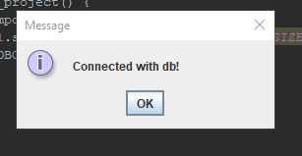Picture 1 - Shows that the application is connected successfully with the database.

Picture 2 - Shows the user inserting some data into the application, calculating the payment, and generating the receipt bill.

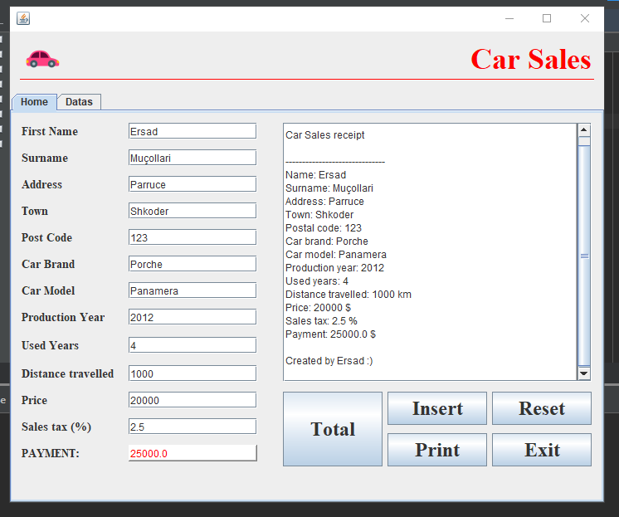

Picture 3 - Shows the user printing the receipt bill.

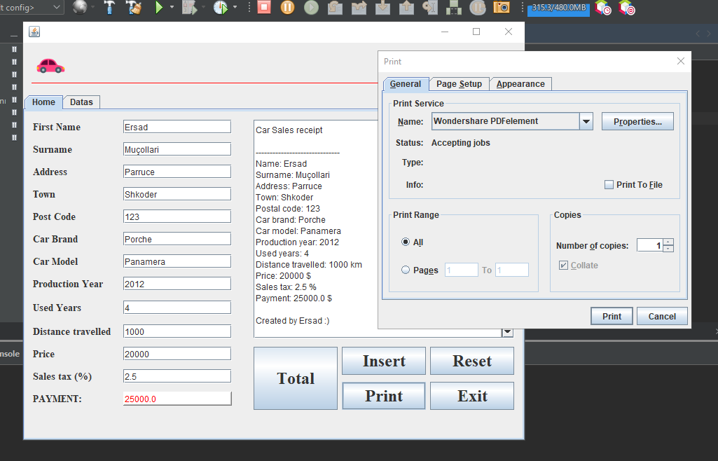

Picture 4 - Shows the bill opened in a Pdf Editor. 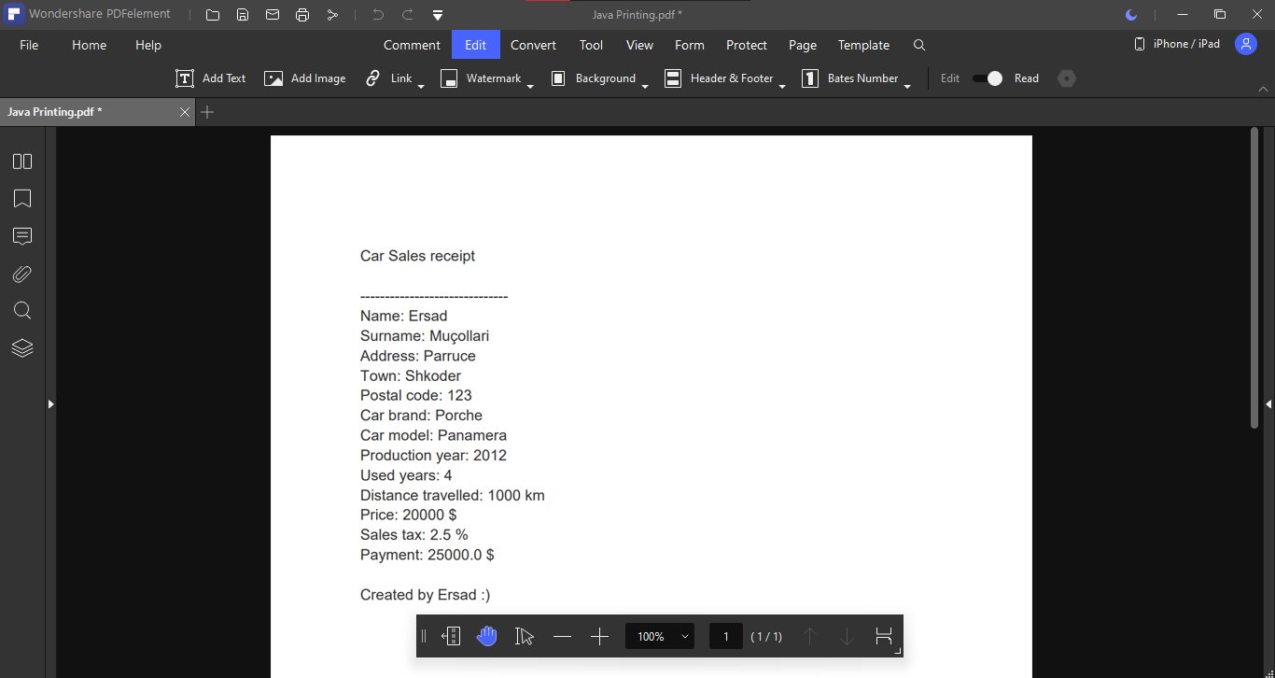

Picture 5 - Shows the user trying to close the application. 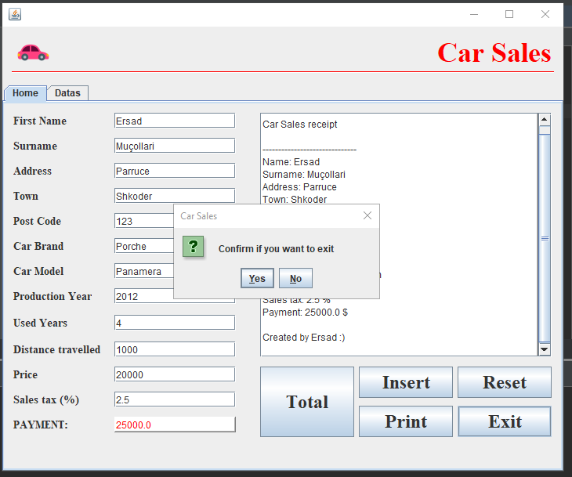

Picture 6 - Shows the data from database organized in a table by the application. 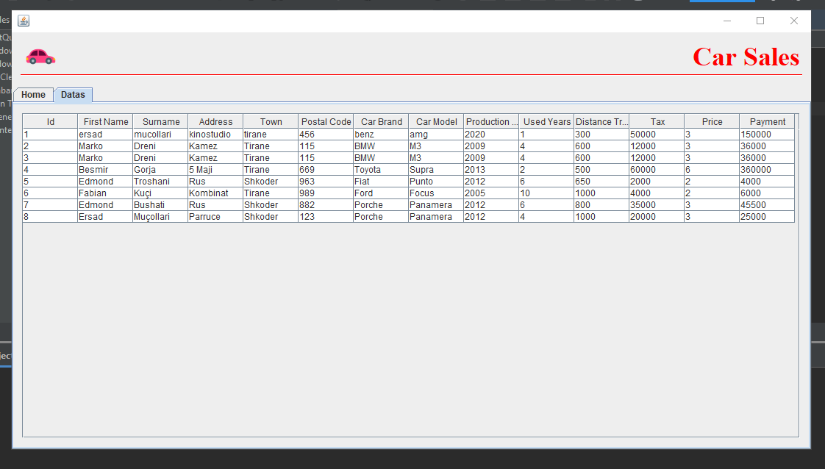

# Introduction

The “Car Sales Management System” has been developed to override the problems prevailing in the practice of the manual system. This software is supported to eliminate and in some cases reduce the hardships faced by the existing system. It also makes the process smoother and more effective.

The application is designed in such a way as to avoid all possible errors while entering the data. It also provides error messages while entering invalid data. No formal knowledge is needed for the user to use this system. It can assist the user to concentrate on their other activities rather than concentrate on the record-keeping.

This system will ultimately allow you to better manage resources.

# The objective of the project on Car Sales Management System

The purpose of the project is to build an application to reduce the manual work for managing and keeping track of the Car, Customer, Payment. The project is built at the administrative end and thus only the administrator has guaranteed access.

# Functionalities provided by Car Sales Management System

* It tracks all the information of Car, Customer, Payment.
* Shows the information of Car, Customer, Payment in a table.
* Calculate the payment based on the price of the car and its tax.
* Generate the receipt bill.
* Integration of all records in order.

# Scope of the project Car Sales Management System

This application will help the user to know the management of passed year perfectly and vividly. It will help to reduce the cost of collecting these data and will make sure the process will go smoothly.

* In the application, the user has to fill in various text fields.
* A receipt bill will be generated and printed.
* Utilization of resources in an efficient manner by increasing productivity through automation.
* Good user interface.

# Software Requirements

|  |  |
| --- | --- |
| **Name of component** | **Specification** |
| Operating system | Windows 7, Windows 8, Windows 10, Linux |
| Language | Java 2 runtime environment |
| Database | MySQL Server |
| Browser | Any of Mozilla, Opera, Chrome, etc |
| Webserver | Tomcat 7 |
| Software development kit | Java JDK 1.7 or above |
| Scripting language enable | JSP (Java Server Pages |
| Database JDBC drive | MySQL Jconnector |

# Modules of Car Sales Management System

* Car Module: Used for managing the Car details.
* Client Module: Used for managing the Client details.
* Payment Module: Used for managing the payment information.
* Receipt Bill: Generated by the system for the client.
* Clients Table Module: Used for keeping track of all clients in a single place.

# Conclusion

This Java Application provides a computerized version of the car sales management system which will benefit all car shop administrators as well as the clients of the shop.

It makes the entire process easier and more organized where the administrator can calculate the final price of the car based on its tax percentage, store his client’s data in the database, manage these data and generate a receipted bill for each client.

# References

[1] Tutus Funny (2020). Car Sales System Project using Java and Mysql. [online] Available at: <https://www.youtube.com/watch?v=T8FwfeMPwwg&list=WL&index=19&t=208s> [Accessed 13 February 2022].

[2] www.javatpoint.com. 2022. Java Tutorial | Learn Java Programming - javatpoint. [online] Available at: <https://www.javatpoint.com/java-tutorial> [Accessed 13 February 2022].

[3] Deitel, P. and Deitel, H. (2011). Java™ How to Program. Retrieved from https://books-library.net/files/download-pdf-ebooks.org-1489929113Bv7P9.pdf